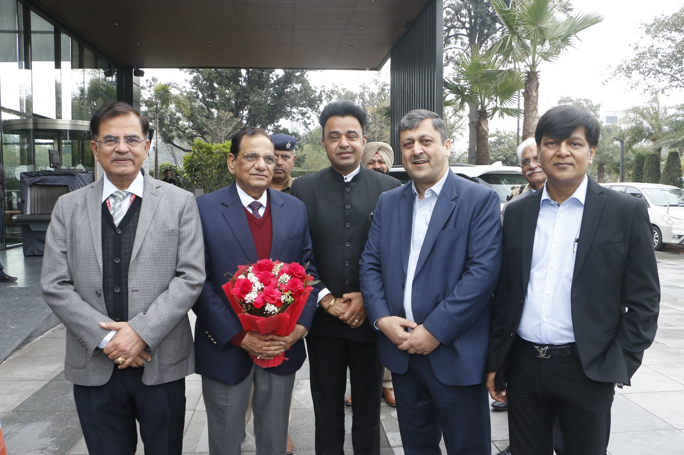

**Building a Future-Ready Healthcare Workforce: NSDC International role in Expanding Skilling for National and Global Needs  
or  
NSDC International paves India’s path to becoming global care capital through care workforce skilling**

**Chandigarh, February 15, 2025** – India’s care sector is at a crucial juncture, requiring a strengthened workforce to meet both national and global demands. In a summit -Transforming the future of the skilled workforce in the care sector – organised by NSDC international in Chandigarh, **Shri** **V.K. Paul, Member (Health), NITI Aayog,** emphasized the need to expand skilling initiatives beyond traditional medical education, balancing quality with quantity.

Talking about skilling initiatives, Shri **Paul** said that the **NSDC International** is playing a pivotal role in this effort, ensuring care professionals trained in India are globally employable. He highlighted the importance of evolving curriculum, strengthening regulatory frameworks, and scaling up skill-based training programs to address workforce shortages, including in specialized areas such as geriatric care. He said, “The private sector collaboration is essential to bridge the skill gap. With structured policies and strong industry-academia partnerships, India can enhance its healthcare skilling ecosystem and emerge as a key contributor to the global workforce.”

The summit witnessed participation of vice chancellors from 50 institutions and around dozen AIIMS chief working towards a stronger healthcare ecosystem.

**Shri** **Paul** further said, “India's healthcare workforce is a critical asset to both the nation and the world. With increasing global demand for skilled professionals, structured skilling initiatives play a pivotal role in equipping our workforce with the expertise required to meet international standards. The efforts of NSDC International in developing a highly trained Care talent pool have significantly contributed to this vision, enabling professionals to excel in diverse healthcare environments. By strengthening skill development and placement pathways, we are not only addressing workforce requirements domestically but also enhancing India's position as a trusted provider of skilled Care professionals across the globe."

Adding to this**, Alok Kumar, CEO, NSDC International said**," With a projected global shortage of 15 million Caregivers by 2030, the demand for skilled professionals is at an all-time high. Countries like Germany, Japan, and Canada have increased their intake of international Caregivers by over 30% in the last two years alone. India, with its young and skilled workforce, has the potential to bridge this gap. At NSDC International, we are committed to developing a globally competent caregiver workforce by aligning skilling programs with international accreditation, streamlining certification processes, and integrating cultural adaptability training. By fostering strategic global partnerships, we aim to position India as a trusted provider of skilled care professionals, creating dignified employment opportunities while strengthening global healthcare systems.”

The summit fostered meaningful discussions on policy recommendations and strategic initiatives aimed at building a sustainable and future-ready care-giver workforce. A key highlight was the dialogue between Vice Chancellors and Directors of leading healthcare institutions, exploring the pivotal role of education in bridging the healthcare worker gap. By strengthening collaboration between academia, industry, and policymakers, the summit set the stage for innovative solutions that will enhance skilling, workforce mobility, and India's contribution to the global healthcare ecosystem.

**About NSDC and NSDC International**

Giving boost to Indian Government Skill India Mission, NSDC, a nodal skill development agency, working under the Ministry of Skill Development & Entrepreneurship (MSDE), Government of India, is a unique Public Private Partnership (PPP) that aims to catalyze the creation of a large and quality vocational training ecosystem in India. Since inception, NSDC has trained over three crore people in different sectors through its collaboration with training partners pan India. NSDC has established 37 Sector Skill Councils (SSCs) and implements the Government’s flagship skill development schemes such as Pradhan Mantri Kaushal Vikas Yojana (PMKVY), National Apprenticeship Promotion Scheme (NAPS), among others. NSDC also funds enterprises, companies and organizations that provide skill training. The organization enables private-sector capacity building in skill development by offering concessional loans, other innovative financial products, and strategic partnerships.

NSDC International is a 100% subsidiary company of NSDC that is enabling the Skill India International objectives to make India a global source for quality talent, provide global job opportunities for resident Indians, provide global career mobility for overseas Indians, and create an internationally benchmarked quality skills ecosystem. NSDC International aims to position India as the preferred hub for supply of skilled workforce across the globe. NSDC International plays a pivotal role in creating enabling systems and steering national and international partnerships for overseas employment through specific programs, mapped to global job requirements and benchmarked to international standards. In addition, it also aims to leverage NSDC’s existing knowledge base and experiential learning to provide technical services for skill development.