**India-Israel Workforce Collaboration Reaches New Heights, Massive Turnout at ITI Aundh, Pune for Israel Recruitment Drive**

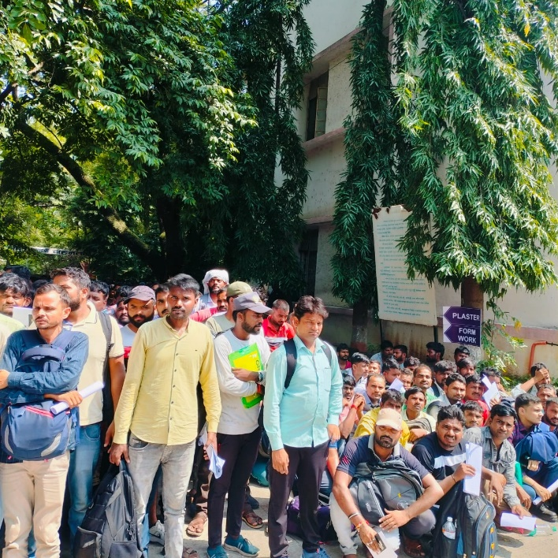

**Pune, India, September 22, 2024:** The strategic workforce partnership between India and Israel has entered an exciting new phase as thousands of skilled Indian workers flock to ITI Aundh, Pune, for the second round of a ground-breaking recruitment initiative.

This drive, which commenced on September 17 and will run through September 25, 2024, marks a significant milestone in international labour cooperation.

A delegation of 12 Israeli officials arrived in India on September 16 to oversee this ambitious recruitment effort. Their presence underscores the importance of this initiative, which aims to fulfill Israel's growing demand for skilled construction workers while offering Indian talent unprecedented international career opportunities.

The current phase of recruitment builds upon the resounding success of the initial drive conducted earlier this year in Haryana, Uttar Pradesh and Telangana. To date, approximately 4,800 Indian workers have already been deployed to Israel, earning competitive salaries of around Rs 1.32 lakh per month and a monthly bonus of Rs 16,000. An additional 1,500 workers from the first cohort began their journey to Israel on September 18, 2024, bringing the total number of skilled Indian professionals in Israel to over 5,000.

Encouraged by these positive outcomes, Israeli employers have expanded their recruitment targets, seeking an additional 10,000 candidates in this round. The focus remains on four critical areas of expertise: Framework, Iron Bending, Plastering, and Ceramic Tiling.

This initiative is the fruit of a landmark Government-to-Government (G2G) agreement signed between India and Israel in November 2023. The Maharashtra Government has shown its full support behind the program, providing crucial infrastructure and logistical support at ITI Aundh. Deputy Director and in-charge Joint Director Ramakant Bhavsar, along with his team, are spearheading the recruitment efforts at the institute.

The National Skill Development Corporation (NSDC) plays a pivotal role in this process, ensuring that India's skilling programs align with global employment demands. Their tireless efforts guarantee that candidates are well-prepared for the technical and professional challenges they will face in Israel.

This recruitment drive represents a significant step in India's journey to become a global supplier of high-quality human resources. It showcases the nation's commitment to enhancing employment opportunities for its workforce in international markets, particularly in countries that value Indian expertise in labour-intensive industries.

As this initiative continues to gather momentum, it sets a powerful precedent for international labour mobility and demonstrates the mutual benefits of collaborative partnerships between nations. The success of this program is expected to pave the way for many more such international placement opportunities in the future, further cementing India's position as a key player in the global skilled workforce arena.